Assignment 2 Digital and Analog Input & Output

Released Date: September 26th

Version 1.0

**Task 1** Specify and mark **Arduino Uno onboard Digital and Analog Pins.**

任务1 描述和标注Arduino Uno板上的数字引脚和模拟引脚。

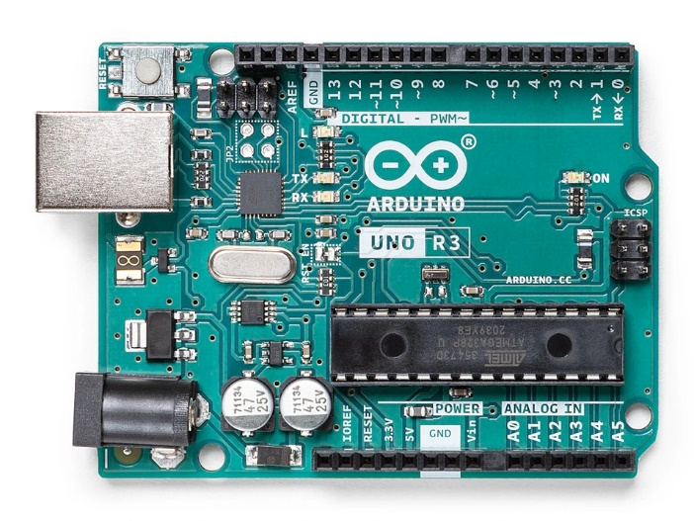

模拟引脚

数字引脚

Fig 2 Arduino Uno Board

**Task 2 One** LED is linked with the **digital pin**, set up a circuit to use **a button (or two)** to control the on and off state of the LED. Draw the circuit in TinkerCAD, make the executable codes for the function.

任务2 一个LED与数字引脚相连，设置一个电路，用一个（或两个）按钮来控制LED的开启和关闭状态。在TinkerCAD中绘制电路，编写功能的可执行代码。

Fig 2 Circuit

int buttonState = 0;

void setup()

{

pinMode(2, INPUT);

pinMode(LED_BUILTIN, OUTPUT);

}

void loop()

{

buttonState = digitalRead(2);

if (buttonState == HIGH) {

digitalWrite(LED_BUILTIN, HIGH);

} else {

digitalWrite(LED_BUILTIN, LOW);

}

delay(10);

}